


Big Data
No. | Name | Section | ID
1 | Rufaida Muhammed Sayed Ahmed | 1 | 9202550
2 | Rawan Ahmed Fouad | 1 | 9220302

Lab 6 – Logistic Regression

Contents
Question1 3
Question2 3
Question3 3
Question4 3
Question5 4
Question6 5
Question7 5
Question8 5
Question 9 6

Question1

What are the variable pairs that are not correlated at all to each other?
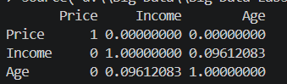
from the correlation matrix the pairs that are not correlated are (Price, Income) and (Price, Age)

Question2

Are there any highly correlated variables in this dataset?
No, there is a weak correlation between (Age, Income) but this is not high and there is no other correlation.

Question3

How many categories are there for the Price variable?

3 Categories (10,20,30)

Question4

Why is it divided into two entries only in the model?
Because logistic regression uses dummy variables, one category is taken as a reference variable.
So if there are 3 categories only 2 variables are created.
In our case there is 3 categories 10,20,30 the 10 is the reference variable and there is two Boolean variables (price_20, price_30) so if the price value is 10 (price_20 =0 , price_30= 0)

Question5

- Write the value of AUC.
0.915272
2. What is the maximum value of AUC (ideal case)?
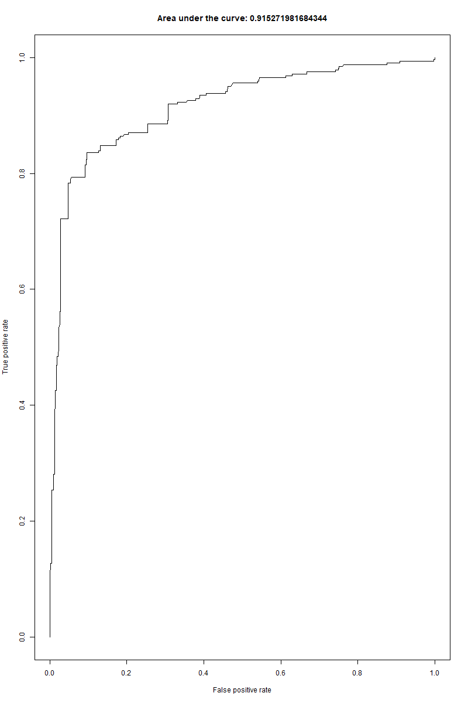
The maximum value of AUC is 1, which represents a perfect classifier

Question6

What does each point in the ROC graph represent?
In other words, what is the value that changes and drives TPR and FPR to change
too from one point to another in the graph?

Each point on the ROC curve represents a different classification performance at a specific threshold.
To control the TPR and the FPR use the threshold as Changing the threshold changes both:
- True Positive Rate (TPR)
- False Positive Rate (FPR)

Question7

How is the predicted probability affected by changing only Price holding all other
variables constant?

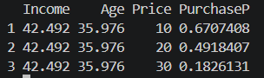
As the price increases while the other features are constant the purchase probability decreases.

Question8

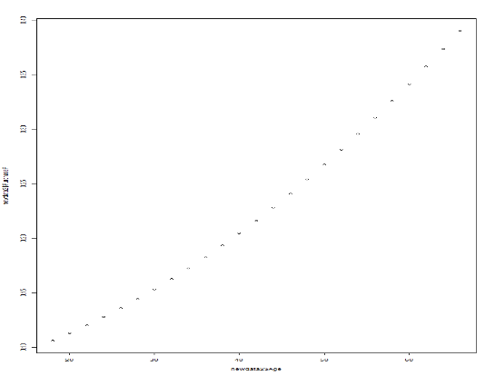
How is the predicted probability affected by changing only Age holding all other
variables constant?

As the Age Increases while other features are constant
the purchase probability increases this means
that there is a direct proportion between them.

Question 9

How is the predicted probability affected by changing only Income holding all other
variables constant?
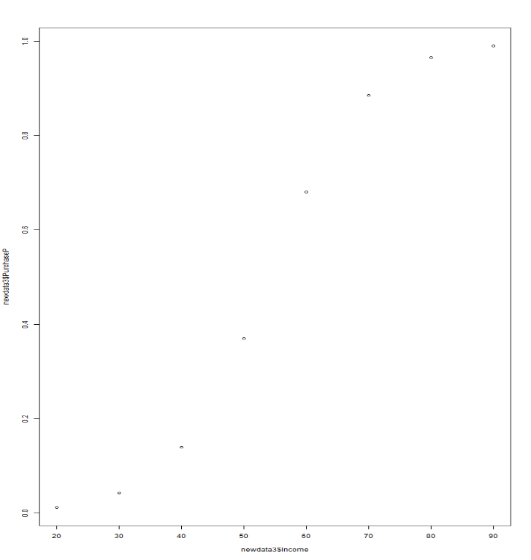

As the Income Increases while other features are constant the purchase probability increases this means that there is a direct proportion between them.

